CHAPTER 1

INTRODUCTION
A Smart Home System (SHS) refers to a modern household environment where appliances, sensors, and devices are interconnected to provide automation, security, monitoring, and remote control. The evolution of smart technologies has transformed daily living, offering convenience and safety for users of all age groups.
The impact of Smart Home Systems extends beyond technology—it also influences social relationships, especially the relationship between parents and children. With smart devices monitoring activities, optimizing routines, and reducing workload, families experience improved communication, increased safety, and shared responsibilities. This report focuses on how smart home systems shape parent–child relationships, the benefits, challenges, and long-term implications.

PROBLEM STATEMENT
In traditional households, parents often face challenges such as:
    - Limited visibility into children’s daily routines.
    - Difficulty balancing work, safety monitoring, and parenting tasks.
    - Communication gaps caused by busy work schedules.
    - Concerns about home security and children’s independent behavior.
Smart Home Systems aim to address these challenges by offering real-time monitoring, automated reminders, interactive home environments, and communication-enhancing technologies. However, increased automation may also affect emotional bonding and independence if misused.

OBJECTIVES
The objectives of this report are:
    - To study how Smart Home Systems influence communication between parents and children.
    - To analyze the role of smart devices in child safety and supervision.
    - To understand how automation impacts family bonding and shared responsibilities.

    - To identify challenges, psychological effects, and ethical concerns related to smart home monitoring.
    - To propose a balanced approach for healthy parent–child relationships in smart households.

SCOPE
This study focuses on:
    - Smart home components: sensors, cameras, voice assistants, automation hubs.
    - Behavioral changes in family dynamics due to automation.
    - Impact on children's responsibility, independence, and learning.
    - Emotional benefits such as enhanced bonding and reduced stress.
    - Potential drawbacks like over-monitoring and privacy concerns.

CHAPTER 2

LITERATURE SURVEY

INTRODUCTION TO SMART HOME SYSTEM
Smart homes are residences instrumented with sensors, actuators, and networked devices that provide automation, remote control, monitoring, and context-aware services. Over the last decade research has expanded from single-device automation to integrated IoT ecosystems addressing energy management, security & privacy, human-centered design, and AI-driven personalization. A number of systematic surveys and review papers synthesize this fast-moving field and identify recurring challenges in interoperability, trust, and scalability.

METHODOLOGY FOR THIS SURVEY
This survey synthesizes recent systematic reviews, scoping reviews, and topical surveys (2020–2025) across computer science, IoT, human–computer interaction, and energy systems.
I prioritized review articles and papers that,

    - present taxonomies/architectures,
    - analyze security/privacy threats,
    - review energy management, and
    - examine user acceptance and human-centered concerns.

TAXONOMY & REFERENCE ARCHITECTURES
Researchers commonly classify smart-home systems into layered architectures: device (sensors/actuators), network/communication, middleware/platform (hubs, cloud), and application/user interface layers. Works compare edge vs. cloud processing and hybrid architectures that push computation to gateways for latency, privacy, and reliability reasons. Common design goals are modularity, standard interfaces, and support for heterogenous protocols (Zigbee, Z-Wave, BLE, Wi-Fi, Thread, MQTT/CoAP).

COMMUNICATION TECHNOLOGIES & INTEROPERABILITY

A persistent research focus is interoperability among devices from multiple vendors. Studies review low-power wireless protocols (Zigbee, Z-Wave, BLE), IP-based approaches (6LoWPAN, Thread), and application protocols (MQTT, CoAP). Middleware frameworks, standardization efforts, and home gateways are frequently proposed to translate protocols and supply a uniform API. Interoperability remains an unsolved practical barrier for large- scale, vendor-agnostic deployments.

ENERGY MANAGEMENT & DEMAND RESPONSE
Smart Home Energy Management Systems (HEMS) are a major area: forecasting household demand, scheduling appliances, integrating distributed generation (solar), EV charging coordination, and dynamic pricing response. Recent surveys review forecasting models, optimization strategies, and integration with smart grid services. Research trends emphasize forecasting accuracy, user comfort constraints, and economic incentives.

SECURITY & PRIVACY
Security and privacy are repeatedly highlighted as critical issues: weak device authentication, firmware vulnerabilities, insecure cloud backends, eavesdropping on radio links, and privacy risks from data collection (audio, video, occupancy). Surveys propose layered defenses (secure boot, mutual authentication, encryption), intrusion detection, access control models, and privacy-preserving data aggregation. However, trade-offs between usability and strong privacy/security remain challenging in consumer deployments.

CHAPTER 3

SYSTEM REQUIREMENTS

SOFTWARE REQUIRMENTS
- Operating System: Windows 10 / Linux
- Frontend: HTML, CSS, Bootstrap, JavaScript
- Backend: PHP

- Database: MySQL
- IDE/Tools: XAMPP, Notepad++, Arduino IDE (for IoT setup)++

SOFTWARE DESCRIPTION

XAMPP(PhpMyAdmin)
      - Used to manage the MySQL database for user authentication and sensor data
      - The Smart Home System requires a reliable local server environment for hosting the backend application and managing its database. XAMPP provides an ideal solution as it integrates multiple essential server components into one package, making development and testing efficient
      - It enables the system to perform data storage, retrieval, and manipulation operations effectively through PhpMyAdmin, which serves as the graphical interface for managing the MySQL database.

PHP
      - Handles backend communication and database connectivity.
      - The Smart Home System is designed to allow users to control devices, monitor sensor readings, and manage logs through a web-based interface. PHP is used to implement this functionality by acting as a middleware that connects the user interface (HTML, CSS, JavaScript) to the MySQL database (via XAMPP).

BOOTSTRAP

      - In the Smart Home System, Bootstrap plays a crucial role in creating a clean, responsive, and consistent user interface for controlling devices, viewing sensor data, and managing system activities. It ensures that the web application adapts smoothly to different screen sizes — from desktops to mobile devices — making it accessible anytime, anywhere.
      - Provide Responsible Web Interface

ARDUINO IDE

      - The Arduino Integrated Development Environment (IDE) is a powerful, open- source platform used for writing, compiling, and uploading Code to Arduino microcontrollers.
      - In the Smart Home System, the Arduino IDE is used to program and control various hardware components such as sensors, actuators, and IoT modules (ESP8266/ESP32) that form the core of the system’s automation and monitoring functionalities.

PROBLEM ANALYSIS
- The traditional home systems require manual operation and offer limited monitoring. Users lack real-time updates and remote control. The proposed system automates these processes and integrates IoT for improved efficiency.

OPERATIONAL FEASIBILITY
- Operational feasibility evaluates how effectively the proposed Smart Home System can function in a real-world environment. It focuses on determining whether the system will operate successfully once developed and deployed, ensuring that it meets the users’ needs and integrates smoothly with existing household infrastructure.
- In this project, operational feasibility assesses the practicality of implementing and maintaining the IoT-based Smart Home System from a user, technical, and environmental perspective.
- The system is user-friendly and can be operated by anyone with basic smartphone or computer knowledge. Minimal maintenance is required

CHAPTER 4
DESIGN AND IMPLEMENTATION
4.1 DESIGN
A smart home system integrates sensors, actuators, and intelligent software to automate home tasks, improve security, enhance energy efficiency, and provide convenient control via mobile or voice interfaces. The system typically uses IoT (Internet of Things) technologies to enable communication between devices.
The design of a smart home system involves:

- Hardware components (sensors, actuators, controllers)
- Network and communication technologies
- Software interfaces (mobile/web apps, dashboards)
- Data processing and automation mechanisms
- Security and access control
- User experience design

These components work in harmony to create an environment where devices react to user commands or predefined rules and behave autonomously to increase convenience and safety.

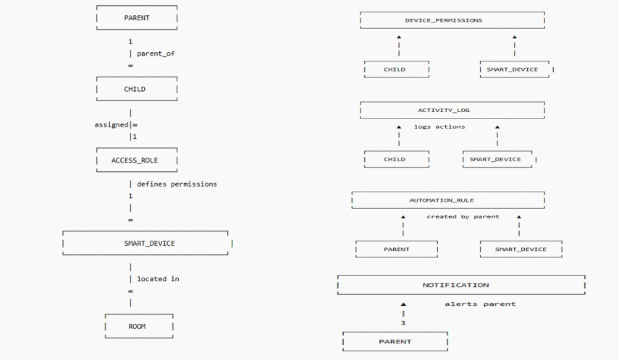

Fig 4.1 : Flow steps

4.2 ER DIAGRAM
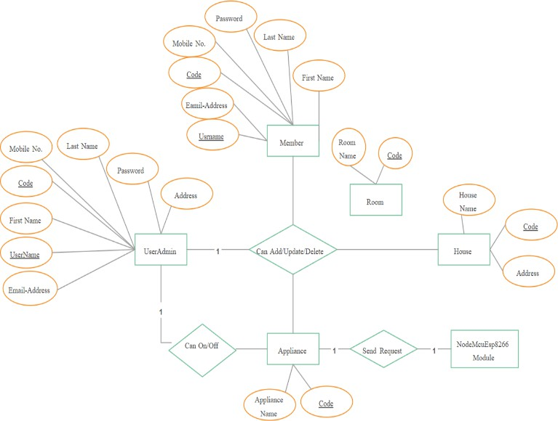
Fig 4.2 : ER Diagram

TRIGGER
If any invalid input (e.g., wrong device ID or empty field) is entered, the system displays an alert message such as “Invalid Device ID.”
1. Condition: Only at night. 2. Action: Turn on the living room light.
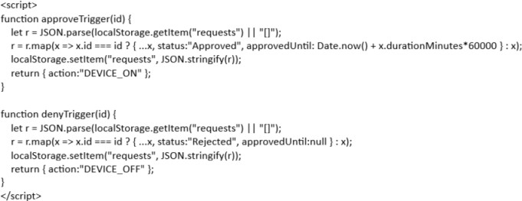

PROCEDURE
A stored procedure retrieves and updates device information: SELECT device_name, status FROM devices WHERE uid = 'user_id';

NORMALIZATION
All database tables follow 3NF:

- 1NF: All attributes contain atomic values.
- 2NF: No partial dependency.
- 3NF: No transitive dependency.

TESTING
The purpose of testing the Smart Home System is to ensure that all functionalities such as user authentication, device control, sensor data monitoring, and log maintenance perform as expected. This report outlines the various testing methods, test cases, and outcomes used to validate the system.
Test ID | Test Case | Expected Result | Actual Result | Status
TC01 | Valid Login | User redirected to dashboard | As expected | PASS
TC02 | Invalid Login | Error message | As expected | PASS
TC03 | Device Control | Device toggled successfully | As expected | PASS

4.6.1 OBJECTIVES

- Verify system functionality and ensure modules interact correctly.
- Validate data accuracy in all database tables (USER, DEVICE, SENSOR_DATA, LOGS).
- Identify and resolve defects or inconsistencies.
- Ensure the system meets performance, security, and usability requirements.

SCOPE

The testing process covers:

- User login and registration modules.
- Device management and control (ON/OFF, status update).
- Sensor data collection and storage.
- Activity log generation and retrieval.

CHAPTER 5

  - HOME PAGE
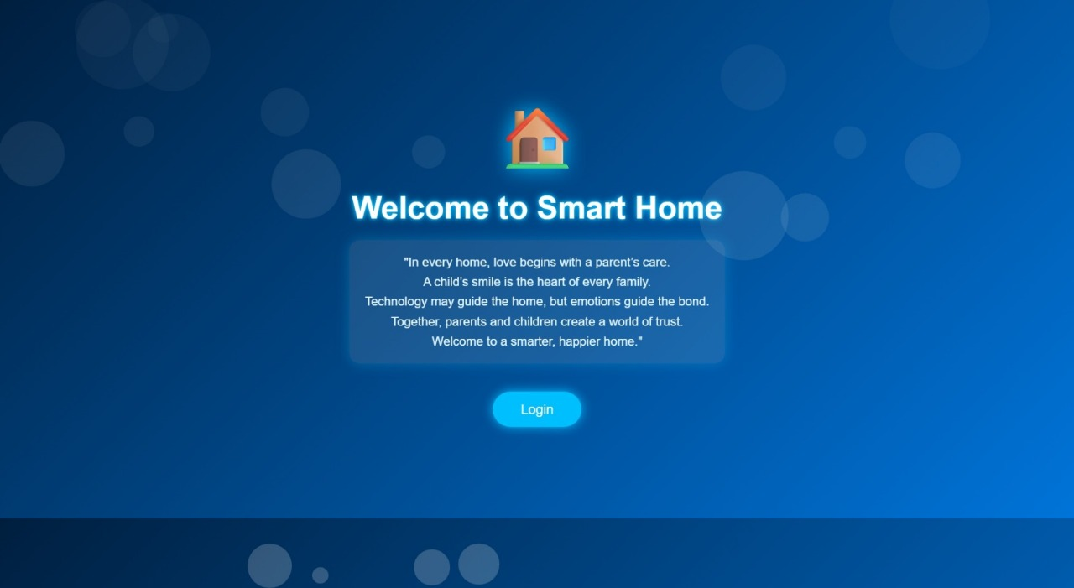

SNAPSHOTS OF PROJECT

Fig 5.1 : Home Page
    - This "home page" is the central control hub of the entire application. It needs to be clean, intuitive, and provide instant access to the most important controls and information.

LOGIN PAGE

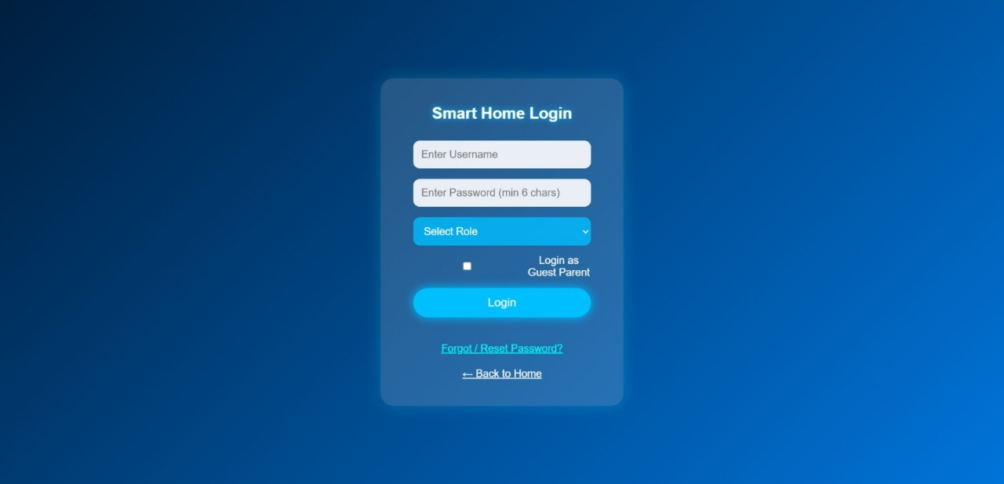

Fig5.2 Login Page
    - It looks like you have the design for the Entry Flow of a Smart Home application. These two screens represent the initial welcome and the subsequent login process.
    - This is the very first screen a user sees, acting as a splash page or landing page for the application.

CHILD DASHBOARD
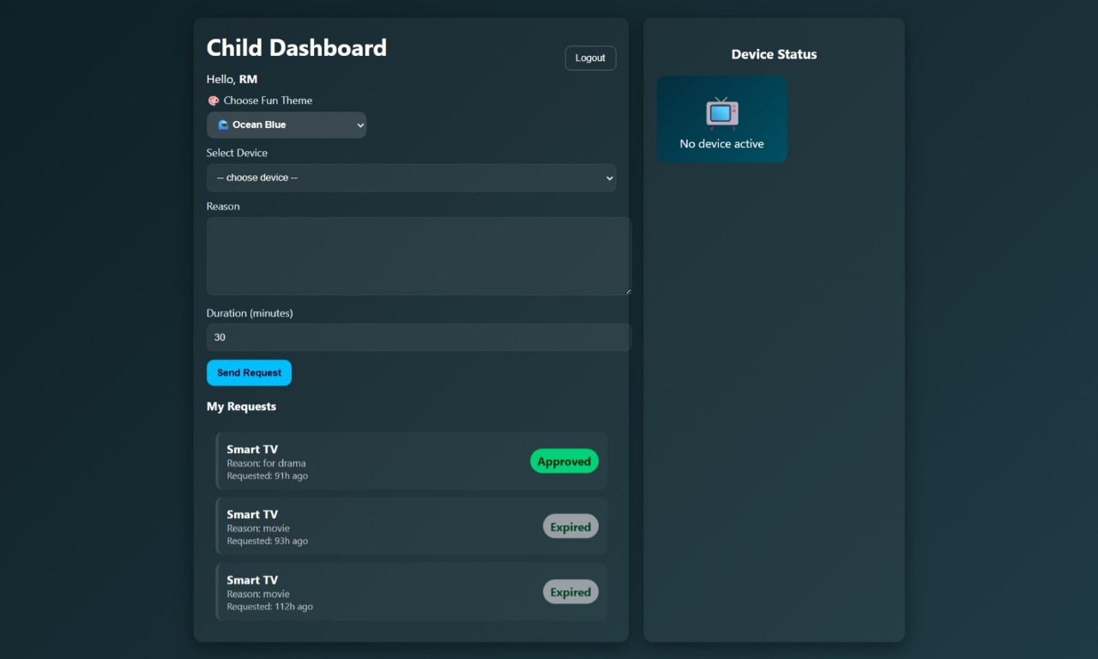

Fig 5.3 : Child Dashboard
    - the security and permission management feature within your Smart Home application, specifically around the Parent/Child roles.
    - This screen is what the user sees after logging in with the "Child" role. Its entire purpose is to facilitate the structured request for device access, which the Parent must approve on their dashboard.

PARENT DASHBOARD
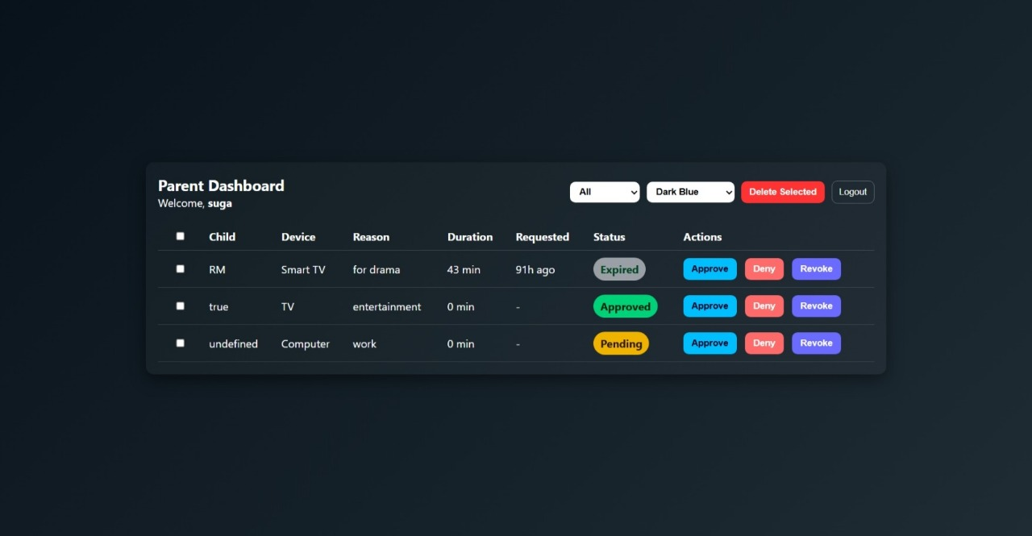
Fig 5.4 : Parent Dashboard
    - the Entry and Initial Dashboard Flow for your Smart Home application, specifically highlighting the Parent/Child access structure introduced in the login screen.
    - This screen is what the user sees after successfully logging in with the "Parent" role from the previous Login screen. It is not the main device control panel, but a specialized administrative panel.

